HOW TO BUILD THE ARM

Guido Bugmann, 14/11/2016 , 06/01/2017

|---------------------------------|

License: TO ADD

|---------------------------------|

Contents

1. Four bars
2. Support plates
3. Sliders
4. Lifting mechanism
5. Basic forces and torque calculations

|---------------------------------|

1. Four bars

The arm is made of four light metal tubes with internal reinforcement where they are traversed by axes.





Fig. Arm tubes and wooden plug dimensions

The total length of each tube is 750+20 = 770mm.

The three 3mm holes in each tube need to be drilled carefully to be parallel to each other.

Three wooden plugs reinforce the tube in critical sections, to prevent damage by the axes. Two 30mm-long plugs are inserted at each end of the tube. A 100mm-long plug is inserted behind the middle hole. Start with the middle plug, put a marker on a rod and used it to hammer the plug in to just the right depth. The wooden bar used (see part&cost spreadsheet) has a very fit, which is good.

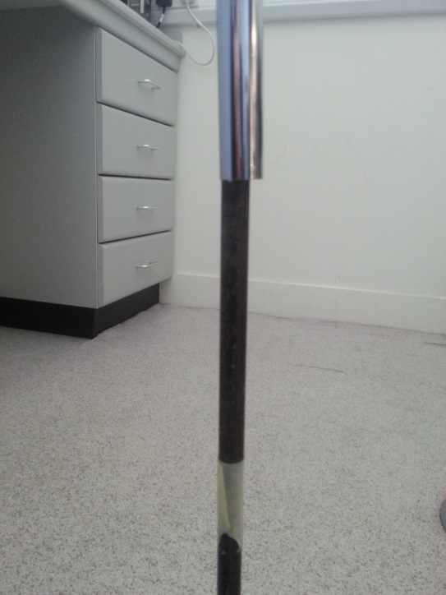 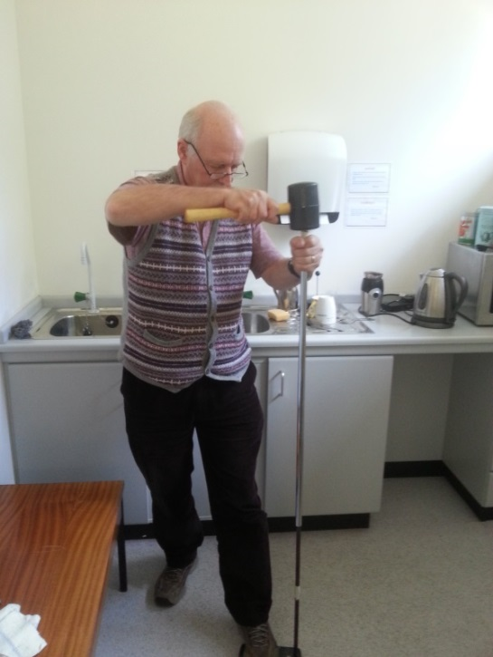

Fig. Inserting the wooden peg toward the middle hole, before drilling the hole.

1. Support plates

The tube holders are made of 3 layers of 3mm thick MDF.

The middle layer has horizontal cuts to create space for a 3mm rod going through the whole width, acting as axis for the two bar at that height.

The back holder plates are pictured below. They have two holes at the lower part for the pull-down cable (see section 4).

See files: v1\3-ARM\2D\splitplate.dxf and plate1.dxf and also their .stp version – but none appears to be editable?

Note: The size of the elongated slots may have changed since the first version, to allow for a larger max and min angle of the arm. The actual length if 45mm and the width 20mm. The vertical distance between axes is 100mm and the horizontal distance between slot centres is 120mm

  

Fig. The three lasercut parts forming the back holder of the arm.

The three plates are held together with M3 nuts and 15 mm bolts.

The central holder is longer, carries four glidder to fit into the rails on each side of the mast, and have a cut in at the top to create space for the top mast pulley when fully lifted.

See file: Finalsliderdwg.dxf (seems to have two copies of the middle layer … -> make a freecad version)



Fig. shape of plates for the middle holder.

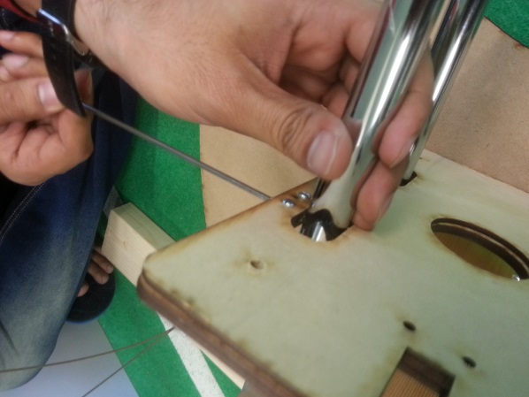

Fig. Mounting the middle holder.

1. Sliders

The middle holder is attached to four sliders

See Arm-Slider files UNIFINISHED

When lifting a heavy load, the bars bush or pull on the middle plate and tend to bend it. For that reason, the glider need a rounded profile. One may consider adding a middle glider on each side, but this requires some thinking to avoid interfering with the movement of the arm bars.

 

The front holder will normally hold the gripper and the camera and has a design depending on the type of gripper. The picture below shows the parts for the current gripper.

Without gripper, the front holder uses the same parts as the back holder.

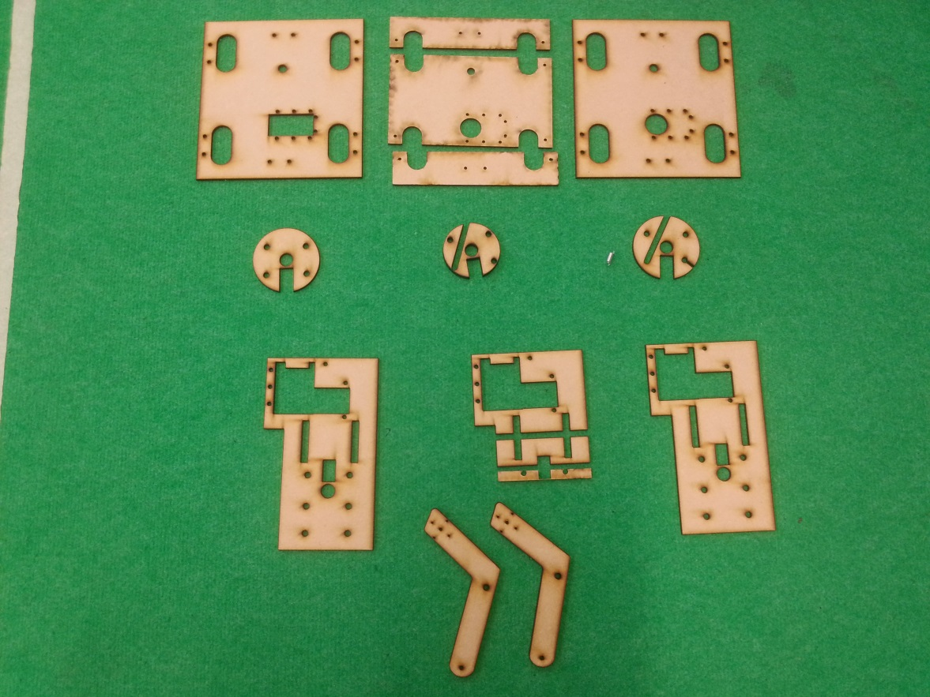

Fig. parts for the front holder and gripper (see instructions for the gripper assembly).

.

1. Lifting mechanism

To implement the concept of “virtual rotation centre” (it is not really an axis of rotation, but it helps thinking about it this way), we need one pull-up cable attached to the middle holder and on pull-down cable attached to the back holder.

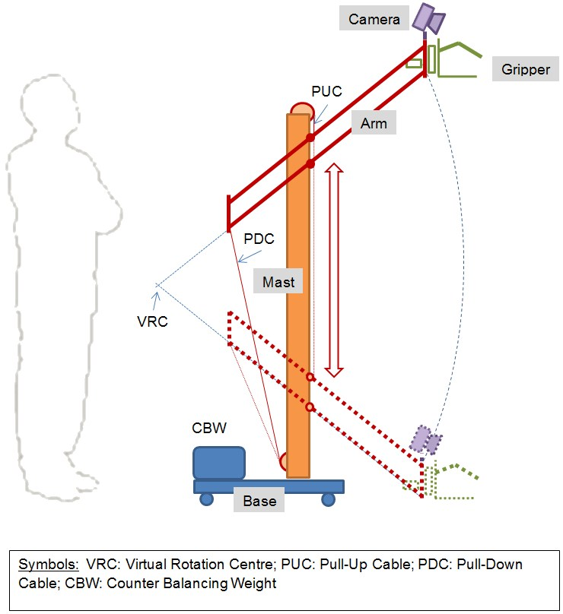

We are using 2mm Dyneema ropes that are strong and have a very low stretch coefficient.

When the pull-up cable travels 1m, the pull-down cable travels 50cm. Both motions can be achieved with a single servo motor actuating a double pulley with a small internal diameter of 13mm for the pull down cable and a 26mm diameter for the pull-up cable. Everything is approximate in our design (the diameter of the pulleys varies with the length of cable rolled around them, and there is an angle to the back holder) but functionally, it is fine.

See file: Design\V1\3-arm\CAD\ dual-pulley.FCStd



A dynamixel RX-64 is used with a holder similar to the wheel holders but resized for the larger RX-64.

See file: Design\V1\3-arm\CAD \rx64-mount.FCStd

The internal axis is the same as for the wheels (with one guide bar). Metal screws are used this time, as no impact is to be expected and the cables have some springiness

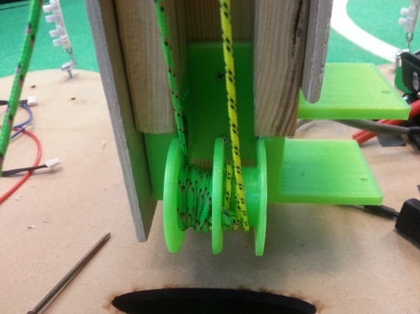 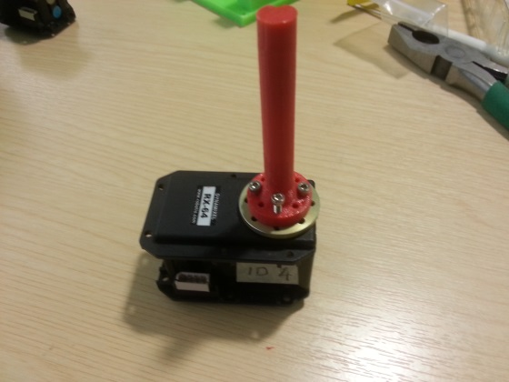

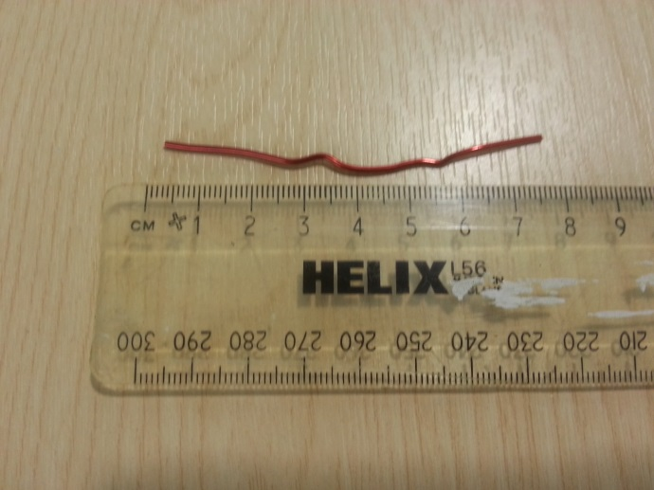 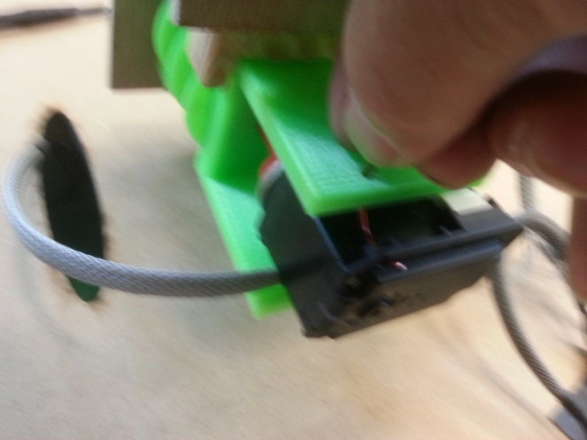

Fig: A small metal wire is used to secure the servo in place (an extra hole should be added in the design of the holder, or some better holding mechanism conceived of).

Cables fitting.

The pulling forces are divided by two by using two additional pulleys.

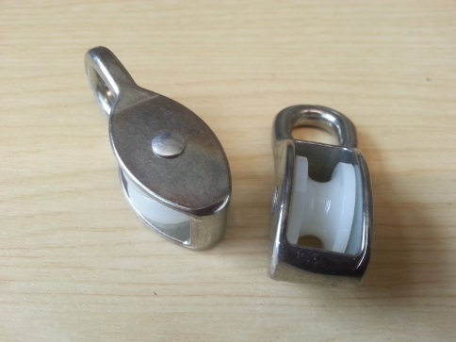

The schema below explains the setup and gives indicative length for the various bits of cable. Please take a good extra margin for knots, adjustments, initial turns on the dual pulley, etc.

 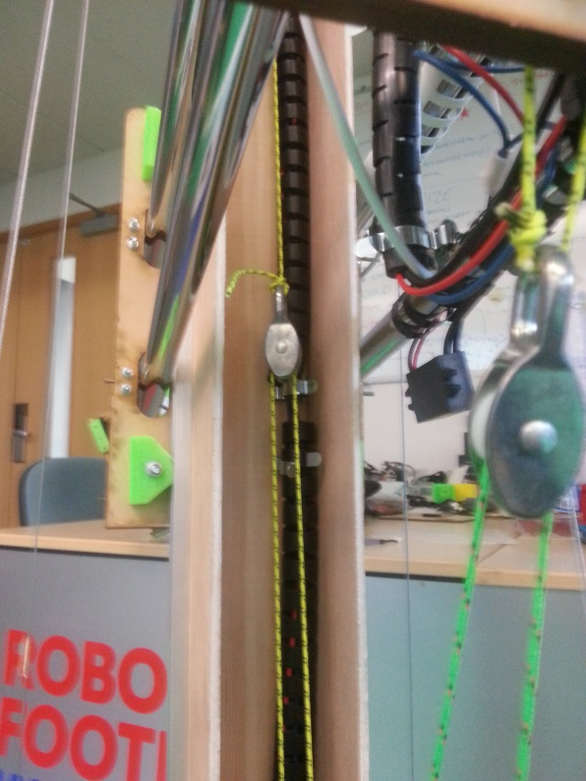

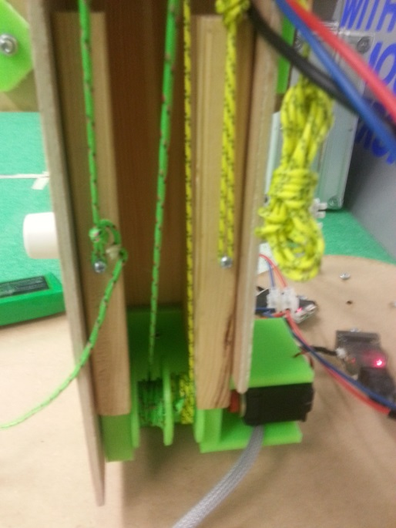

Fig. Pulleys setup (left) and image on the robot (right) and details of cable anchoring on the mast (bottom).

By adjusting the length of the cables on can set the virtual rotation centre to be above the height of a table, so permitting to grab and drop objects on a table. You also need to allow for the arm to reach the floor level.

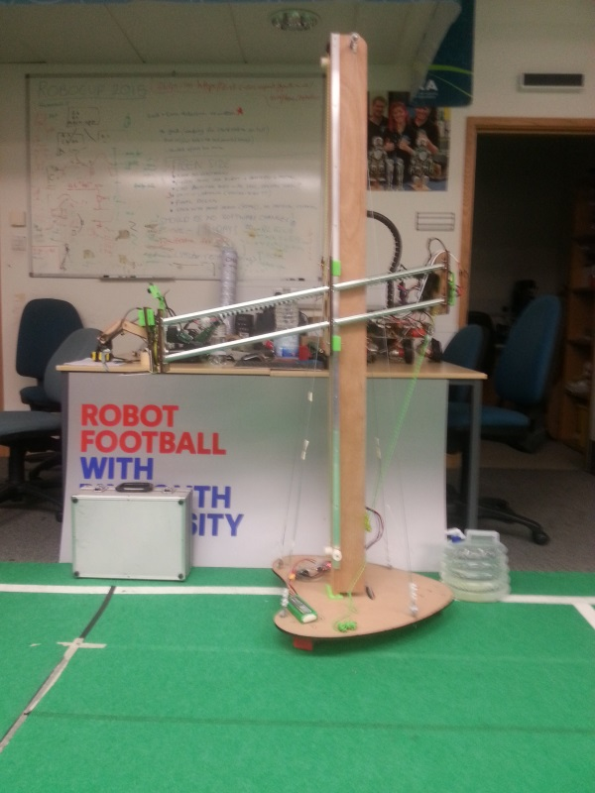 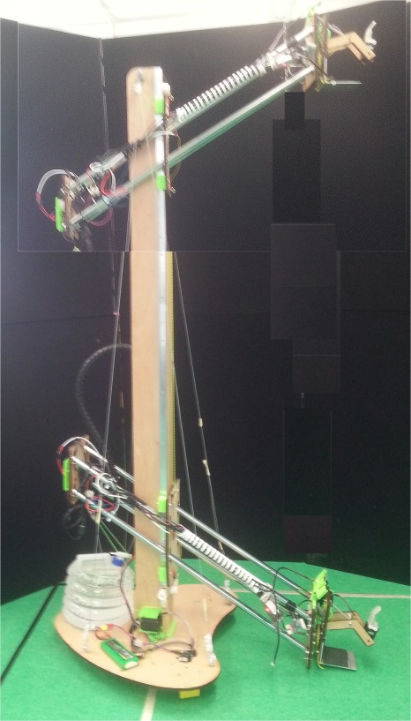

Fig Example of Virtual Rotation Centre placed above the height of a table (left) Composite image showing high and low positions (right)..

To make the adjustments, you could connect the USB2Dynamixel directly to a Windows laptop and drive the servo using the RoboPlus software from Robotis, or use the Pypot Python library if you are working in Linux.

1. Basic forces and torque calculations:

